\

 | INDEX
1 | Write a program to implement Additive Cipher (Z26) with the following conditions: • Plaintext should be in lowercase. • Ciphertext should be uppercase. • Brute force attack.
2 | Write a program to implement Multiplicative Cipher. • Plaintext should be in lowercase. • Ciphertext should be uppercase. • Brute force attack.
3 | Write a program to implement Affine Cipher. • Plaintext should be in lowercase. • Ciphertext should be uppercase. • Brute force attack.
4 | Write a program in to implement Autokey Cipher. • Plaintext should be in lowercase. • Ciphertext should be uppercase. • Brute force attack.
5 | Write a program to implement Vignere Cipher • Plaintext should be in lowercase. • Ciphertext should be uppercase. • Brute force attack.
6 | Write a program to implement Playfair Cipher to encrypt & decrypt the given message where the key matrix can be formed by using a given keyword
7 | W.A.P. to implement Euclidean Algorithm to find the GCD of given numbers.
8 | Write a program to find out the Multiplicative inverse of a given number without using extended Euclidean algorithm
9 | Write a program to implement Elgamal Cryptosystem to generate the pair of keys and then show the encryption & decryption of a given message
10 | W.A.P. to implement RSA Algorithm to generate a pair of keys and show the encryption and decryption by using a given key pair
11 | Write a program to find out the Multiplicative inverse of a given number by using Extended Euclidean algorithm

- Write a program to implement Additive Cipher (Z26) with the following conditions: • Plaintext should be in lowercase. • Ciphertext should be uppercase. • Brute force attack.

import sys

opt = True
while opt:
print("THIS CODE IS FOR ADDITIVE CIPHER CODE")
print("1. Encoding\n")
print("2. Decoding\n")
print("3. Brute Force\n")
print("4. Exit\n")
break

selected_optio= int(input("Enter The Number you want to select:"))

if selected_optio== 1:
while True:
try:
cor = input("Enter Plain Text: \n")
if cor.isupper():
print(cor, "is uppercase value plz Enter Lower Case Value")
elif cor.isdigit():
print(cor, "is an integer value please Enter Valid Input")
else:
print("Valid Input please Continue...")
break;
except ValueError:
print("Provide Valid input")
key = int(input("Enter Key Value: \n"))
ans = ""
for i in range(len(cor)):
ch = cor[i]
if ch==" ":
ans+=" "
elif (ch.isupper()):
ans += chr((ord(ch) + key-65) % 26+65)
else:
ans += chr((ord(ch) + key - 97) % 26 + 97)
print(ans,"<--Here's your Cipher Code")
elif selected_optio== 2:
print("Great Time to Decode Cipher Code")
while True:
try:
cor = input("Enter Cipher Text: \n")
if cor.isupper():
print(cor, "is uppercase value plz Enter Lower Case Value")
elif cor.isdigit():
print(cor, "is an integer value please Enter Valid Input")
else:
print("Keep Going")
break;
except ValueError:
print("Provide Valid input")
key = int(input("Enter Key: \n"))
ans = ""
for i in range(len(cor)):
ch = cor[i]
if ch==" ":
ans+=" "
elif (ch.isupper()):
ans += chr((ord(ch) - key-65) % 26+65)
else:
ans += chr((ord(ch) - key - 97) % 26 + 97)
print(ans,"<--Here's your Plain Text")
elif selected_optio== 3:
ciphertext = input("Enter Cipher Text: \n")
for key in range(1, 26):
plaintext = ""
for char in ciphertext:
if char.isalpha():
plain_char = chr((ord(char) - 65 + key) % 26 + 65)
plaintext += plain_char
else:
plaintext += char
print("Key: {} - Plaintext: {}".format(key, plaintext))
elif selected_optio== 4:
print("Program Terminated...")
sys.exit()

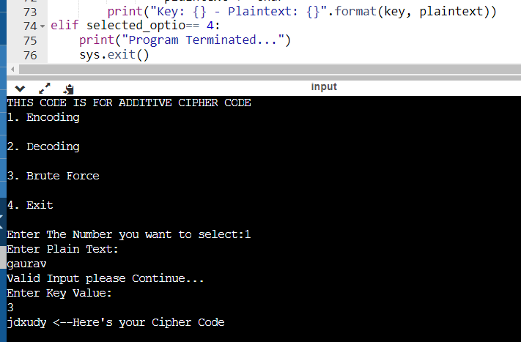

- Write a program to implement Multiplicative Cipher. • Plaintext should be in lowercase. • Ciphertext should be uppercase. • Brute force attack.
import sys
opt = True
while opt:
print("THIS CODE IS FOR MULTIPLICATIVE CIPHER CODE")
print("1. Encoding\n")
print("2. Decoding\n")
print("3. Brute Force\n")
print("4. Exit\n")
break
choice = int(input("Enter The Number you want to select:"))
if choice == 1:
while True:
try:
cor = input("Enter Plain Text: \n")
if cor.isupper():
print(cor, "is uppercase value plz Enter Lower Case Value")
elif cor.isdigit():
print(cor, "is an integer value please Enter Valid Input")
else:
print("Valid Input please Continue...")
break;
except ValueError:
print("Provide Valid input")
key = int(input("Enter Key Value:\n"))
ciphertext = ""
for char in cor:
if char.isalpha():
shift = ord(char.upper()) - 65
shift = (shift * key) % 26
ciphertext += chr(shift + 65)
else:
ciphertext += char
print("Your Cipher Code is: " + ciphertext)
elif choice == 2:
print("Great Time to Decode Cipher Code")
while True:
try:
cor = input("Enter Cipher Text: \n")
if cor.isupper():
print(cor, "is uppercase value plz Enter Lower Case Value")
elif cor.isdigit():
print(cor, "is an integer value please Enter Valid Input")
else:
print("Keep Going")
break;
except ValueError:
print("Provide Valid input")
key = int(input("Enter Key Value in Integer only: "))
plain_text = ""
for char in cor:
if char.isupper():
plain_text += chr((ord(char) - key - 65) % 26 + 65)
else:
plain_text += chr((ord(char) - key - 97) % 26 + 97)
print(plain_text)
elif choice == 3:
ciphertext = input("Enter Cipher Text: \n")
for key in range(1, 26):
plaintext = ""
for char in ciphertext:
if char.isalpha():
plain_char = chr((ord(char) - 65) * key % 26 + 65)
plaintext += plain_char
else:
plaintext += char
print("Key: {} - Plaintext: {}".format(key, plaintext))
elif choice == 4:
print("Program Terminated...")
sys.exit()

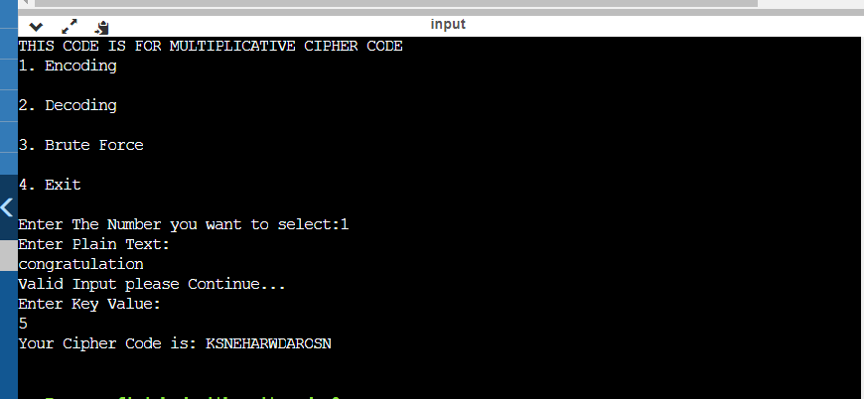

3.Write a program to implement Affine Cipher. • Plaintext should be in lowercase. • Ciphertext should be uppercase. • Brute force attack
import sys
import math
def gcd(a, b):
if b == 0:
return a
else:
return gcd(b, a % b)
def mod_inverse(a, m):
for x in range(1, m):
if (a*x) % m == 1:
return x
return -1
opt = True
while opt:
print("THIS CODE IS FOR AFFINE CIPHER CODE")
print("1. Encoding")
print("2. Decoding")
print("3. Brute Force")
print("4. Exit")
choice = int(input("Enter The Number you want to select: ")
if choice == 1:
while True:
try:
plain_text = input("Enter Plain Text: ")
if plain_text.isupper():
print(plain_text, "is uppercase value please Enter Lower Case Value")
elif plain_text.isdigit():
print(plain_text, "is an integer value please Enter Valid Input")
else:
print("Valid Input please Continue...")
break;
except ValueError:
print("Provide Valid input")
a = int(input("Enter Value of 'a' in the form ax + b: "))
b = int(input("Enter Value of 'b' in the form ax + b: "))
while gcd(a, 26) != 1:
a = int(input("Please Enter a Value of 'a' such that a and 26 are co-prime: "))
ciphertext = ""
for char in plain_text:
if char.isalpha():
shift = ord(char.lower()) - 97
shift = ((a*shift) + b) % 26
ciphertext += chr(shift + 97)
else:
ciphertext += char
print("Your Cipher Code is: " + ciphertext)
elif choice == 2:
print("Great Time to Decode Cipher Code")
while True:
try:
ciphertext = input("Enter Cipher Text: ")
if ciphertext.isupper():
print(ciphertext, "is uppercase value please Enter Lower Case Value")
elif ciphertext.isdigit():
print(ciphertext, "is an integer value please Enter Valid Input")
else:
print("Keep Going")
break;
except ValueError:
print("Provide Valid input")
a = int(input("Enter Value of 'a' in the form ax + b: "))
b = int(input("Enter Value of 'b' in the form ax + b: "))
while gcd(a, 26) != 1:
a = int(input("Please Enter a Value of 'a' such that a and 26 are co-prime: "))
a_inverse = mod_inverse(a, 26)
plain_text = ""
for char in ciphertext:
if char.isalpha():
shift = ord(char.lower()) - 97
shift = (a_inverse * (shift - b)) % 26
plain_text += chr(shift + 97)
else:
plain_text += char
print(plain_text)
elif choice == 3:
ciphertext = input("Enter Cipher Text: ")
for a in range(1, 26):
if gcd(a, 26) == 1:
for b in range(26):
plain_text = ""
for char in ciphertext:
if char.isalpha():
shift = ord(char.lower()) - 97
shift = (a_inverse * (shift - b)) % 26
plain_text += chr(shift + 97)
else:
plain_text += char
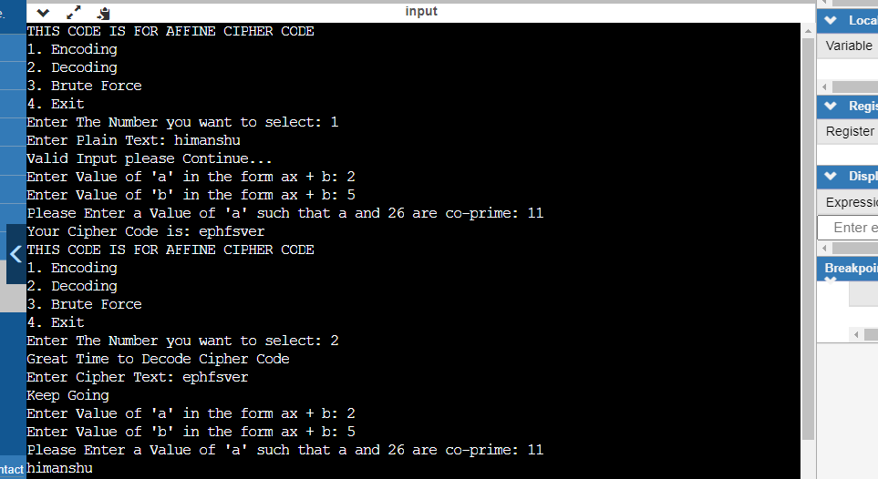

4.Write a program in to implement Autokey Cipher. • Plaintext should be in lowercase. • Ciphertext should be uppercase. • Brute force attack.

import sys

def encode_autokey(plaintext, key):
"""
Encodes plaintext using Autokey Cipher with given key
"""
key = key.upper()
ciphertext = ""
for i, char in enumerate(plaintext):
if char.isalpha():
shift = ord(key[i % len(key)].upper()) - 65
shift = (shift + ord(char.upper()) - 65) % 26
ciphertext += chr(shift + 65)
key += char.upper()
else:
ciphertext += char
return ciphertext

def decode_autokey(ciphertext, key):
"""
Decodes ciphertext encoded using Autokey Cipher with given key
"""
key = key.upper()
plaintext = ""
for i, char in enumerate(ciphertext):
if char.isalpha():
shift = ord(key[i % len(key)].upper()) - 65
shift = (ord(char.upper()) - 65 - shift) % 26
plaintext += chr(shift + 65)
key += chr(shift + 65)
else:
plaintext += char
return plaintext

def brute_force_autokey(ciphertext):
"""
Brute forces the Autokey Cipher by trying all possible key combinations
"""
for key_len in range(1, len(ciphertext)):
for start in range(len(ciphertext) - key_len):
possible_key = ciphertext[start : start + key_len]
possible_plaintext = decode_autokey(ciphertext, possible_key)
print("Key: {} - Plaintext: {}".format(possible_key, possible_plaintext))

opt = True
while opt:
print("THIS CODE IS FOR AUTOKEY CIPHER")
print("1. Encoding\n")
print("2. Decoding\n")
print("3. Brute Force\n")
print("4. Exit\n")

choice = int(input("Enter The Number you want to select:"))

if choice == 1:
plaintext = input("Enter Plain Text: \n").upper()
key = input("Enter Key: \n")
ciphertext = encode_autokey(plaintext, key)
print("Your Cipher Code is: " + ciphertext)
elif choice == 2:
ciphertext = input("Enter Cipher Text: \n").upper()
key = input("Enter Key: \n")
plaintext = decode_autokey(ciphertext, key)
print("Your Plain Text is: " + plaintext)
elif choice == 3:
ciphertext = input("Enter Cipher Text: \n").upper()
brute_force_autokey(ciphertext)
elif choice == 4:
print("Program Terminated...")
sys.exit()
else:
print("Invalid choice. Please select a number from 1 to 4.")
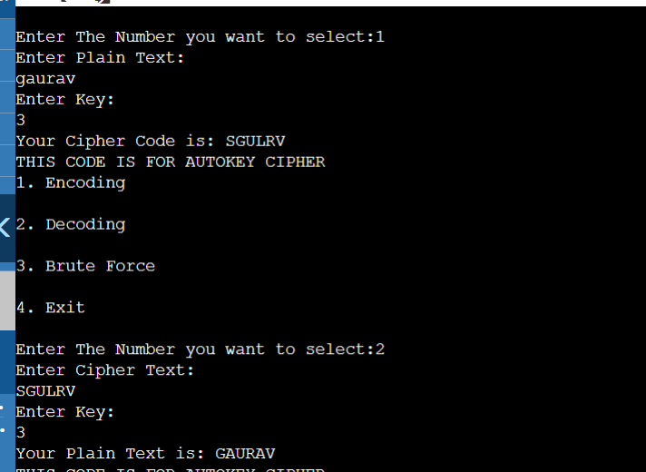
- Write a program to implement Vignere Cipher • Plaintext should be in lowercase. • Ciphertext should be uppercase. • Brute force attack

import sys

def vigenere_encrypt(plain_text, key):
plain_text = plain_text.upper()
key = key.upper()
encrypted_text = ""
for i in range(len(plain_text)):
if plain_text[i].isalpha():
shift = ord(key[i % len(key)]) - 65
shifted_char = chr(((ord(plain_text[i]) - 65) + shift) % 26 + 65)
encrypted_text += shifted_char
else:
encrypted_text += plain_text[i]
return encrypted_text

def vigenere_decrypt(cipher_text, key):
cipher_text = cipher_text.upper()
key = key.upper()
decrypted_text = ""
for i in range(len(cipher_text)):
if cipher_text[i].isalpha():
shift = ord(key[i % len(key)]) - 65
shifted_char = chr(((ord(cipher_text[i]) - 65) - shift) % 26 + 65)
decrypted_text += shifted_char
else:
decrypted_text += cipher_text[i]
return decrypted_text

def vigenere_brute_force(cipher_text):
cipher_text = cipher_text.upper()
for key_length in range(1, len(cipher_text) + 1):
print(f"Brute forcing with key length: {key_length}")
for i in range(26 ** key_length):
key = ""
for j in range(key_length):
key += chr((i // (26 ** j)) % 26 + 65)
decrypted_text = vigenere_decrypt(cipher_text, key)
print(f"Key: {key} - Decrypted text: {decrypted_text}")

opt = True
while opt:
print("THIS CODE IS FOR VIGENERE CIPHER")
print("1. Encoding")
print("2. Decoding")
print("3. Brute Force")
print("4. Exit")
choice = int(input("Enter the number you want to select: "))

if choice == 1:
plain_text = input("Enter plain text: ")
key = input("Enter key: ")
cipher_text = vigenere_encrypt(plain_text, key)
print(f"Your cipher code is: {cipher_text}")
elif choice == 2:
cipher_text = input("Enter cipher text: ")
key = input("Enter key: ")
plain_text = vigenere_decrypt(cipher_text, key)
print(f"Your plain text is: {plain_text}")
elif choice == 3:
cipher_text = input("Enter cipher text: ")
vigenere_brute_force(cipher_text)
elif choice == 4:
print("Program terminated...")
sys.exit()
import sys

def vigenere_encrypt(plain_text, key):
plain_text = plain_text.upper()
key = key.upper()
encrypted_text = ""
for i in range(len(plain_text)):
if plain_text[i].isalpha():
shift = ord(key[i % len(key)]) - 65
shifted_char = chr(((ord(plain_text[i]) - 65) + shift) % 26 + 65)
encrypted_text += shifted_char
else:
encrypted_text += plain_text[i]
return encrypted_text

def vigenere_decrypt(cipher_text, key):
cipher_text = cipher_text.upper()
key = key.upper()
decrypted_text = ""
for i in range(len(cipher_text)):
if cipher_text[i].isalpha():
shift = ord(key[i % len(key)]) - 65
shifted_char = chr(((ord(cipher_text[i]) - 65) - shift) % 26 + 65)
decrypted_text += shifted_char
else:
decrypted_text += cipher_text[i]
return decrypted_text

def vigenere_brute_force(cipher_text):
cipher_text = cipher_text.upper()
for key_length in range(1, len(cipher_text) + 1):
print(f"Brute forcing with key length: {key_length}")
for i in range(26 ** key_length):
key = ""
for j in range(key_length):
key += chr((i // (26 ** j)) % 26 + 65)
decrypted_text = vigenere_decrypt(cipher_text, key)
print(f"Key: {key} - Decrypted text: {decrypted_text}")

opt = True
while opt:
print("THIS CODE IS FOR VIGENERE CIPHER")
print("1. Encoding")
print("2. Decoding")
print("3. Brute Force")
print("4. Exit")
choice = int(input("Enter the number you want to select: "))

if choice == 1:
plain_text = input("Enter plain text: ")
key = input("Enter key: ")
cipher_text = vigenere_encrypt(plain_text, key)
print(f"Your cipher code is: {cipher_text}")
elif choice == 2:
cipher_text = input("Enter cipher text: ")
key = input("Enter key: ")
plain_text = vigenere_decrypt(cipher_text, key)
print(f"Your plain text is: {plain_text}")
elif choice == 3:
cipher_text = input("Enter cipher text: ")
vigenere_brute_force(cipher_text)
elif choice == 4:
print("Program terminated...")
sys.exit()

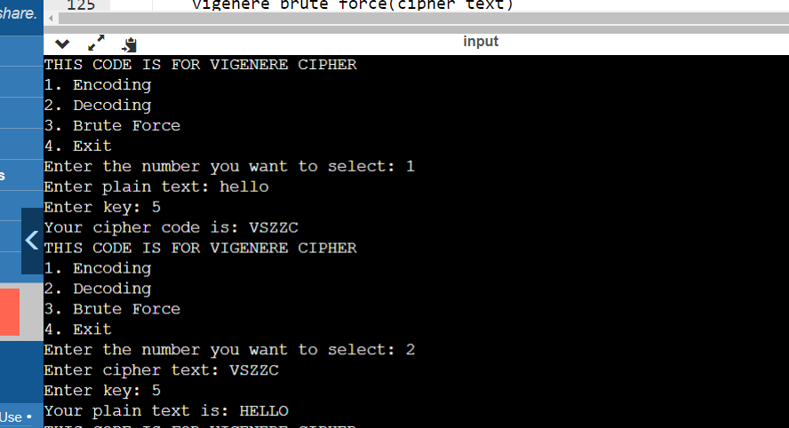

- Write a program to implement Playfair Cipher to encrypt & decrypt the given message where the key matrix can be formed by using a given keyword
import re
def generate_keymatrix(key):
# create key matrix from given keyword
key = key.replace(' ', '').upper()
key = re.sub(r'J', 'I', key)
keymatrix = []
for char in key:
if char not in keymatrix:
keymatrix.append(char)
alphabet = 'ABCDEFGHIKLMNOPQRSTUVWXYZ'
for char in alphabet:
if char not in keymatrix:
keymatrix.append(char)
keymatrix = [keymatrix[i:i+5] for i in range(0, 25, 5)]
return keymatrix

def find_position(keymatrix, char):
# find position of character in key matrix
row = col = 0
for i in range(5):
for j in range(5):
if keymatrix[i][j] == char:
row, col = i, j
break
return row, col

def encrypt(plaintext, key):
# encrypt plaintext using Playfair Cipher
keymatrix = generate_keymatrix(key)
plaintext = plaintext.replace(' ', '').upper()
plaintext = re.sub(r'J', 'I', plaintext)
if len(plaintext) % 2 == 1:
plaintext += 'X'
ciphertext = ''
for i in range(0, len(plaintext), 2):
char1 = plaintext[i]
char2 = plaintext[i+1]
row1, col1 = find_position(keymatrix, char1)
row2, col2 = find_position(keymatrix, char2)
if row1 == row2:
ciphertext += keymatrix[row1][(col1+1)%5]
ciphertext += keymatrix[row2][(col2+1)%5]
elif col1 == col2:
ciphertext += keymatrix[(row1+1)%5][col1]
ciphertext += keymatrix[(row2+1)%5][col2]
else:
ciphertext += keymatrix[row1][col2]
ciphertext += keymatrix[row2][col1]
return ciphertext

def decrypt(ciphertext, key):
# decrypt ciphertext using Playfair Cipher
keymatrix = generate_keymatrix(key)
plaintext = ''
for i in range(0, len(ciphertext), 2):
char1 = ciphertext[i]
char2 = ciphertext[i+1]
row1, col1 = find_position(keymatrix, char1)
row2, col2 = find_position(keymatrix, char2)
if row1 == row2:
plaintext += keymatrix[row1][(col1-1)%5]
plaintext += keymatrix[row2][(col2-1)%5]
elif col1 == col2:
plaintext += keymatrix[(row1-1)%5][col1]
plaintext += keymatrix[(row2-1)%5][col2]
else:
plaintext += keymatrix[row1][col2]
plaintext += keymatrix[row2][col1]
plaintext = re.sub(r'X$', '', plaintext)
return plaintext

plaintext =input("Enter the plaintext Text : ")
key = input("Enter the key : ")
print("plain Text : ",plaintext)
print("Entered Key is : ",key)
ciphertext = encrypt(plaintext, key)

print('Ciphertext:', ciphertext)
decrypted_plaintext = decrypt(ciphertext, key)
print('Decrypted plaintext:', decrypted_plaintext)

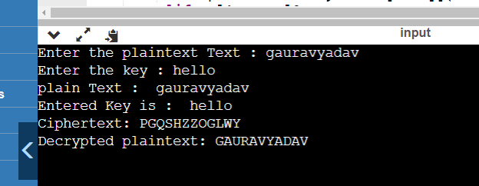

- W.A.P. to implement Euclidean Algorithm to find the GCD of given numbers

def gcd(a, b):
if a == 0:
return b
else:
return gcd(b % a, a)

num1 = int(input("Enter first number: "))
num2 = int(input("Enter second number: "))

gcd_value = gcd(num1, num2)

print("The GCD of", num1, "and", num2, "is:", gcd_value)
def gcd(a, b):
if a == 0:
return b
else:
return gcd(b % a, a)

num1 = int(input("Enter first number: "))
num2 = int(input("Enter second number: "))

gcd_value = gcd(num1, num2)

print("The GCD of", num1, "and", num2, "is:", gcd_value)

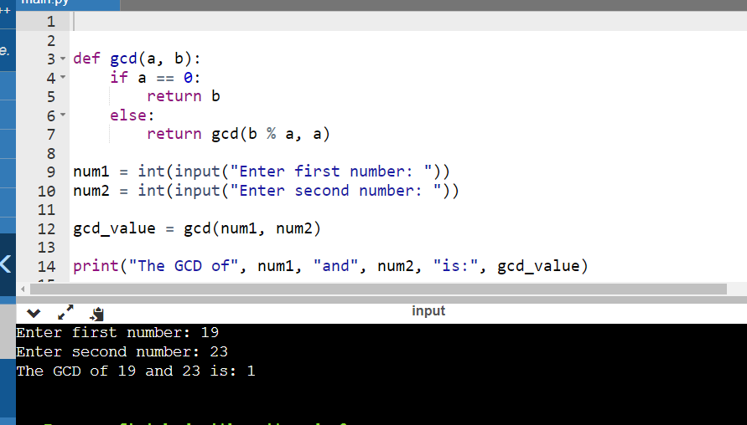

- Write a program to find out the Multiplicative inverse of a given number without using extended Euclidean algorithm

def multiplicative_inverse(n, mod):

for i in range(mod):
if (i * n) % mod == 1:
return i
return None

n = int(input("Enter Number Value of n : "))
mod = int(input("Enter the value of Mod : "))
inverse = multiplicative_inverse(n, mod)
if inverse is not None:
print(f"The multiplicative inverse of {n} modulo {mod} is {inverse}")
else:
print(f"{n} has no inverse modulo {mod}")
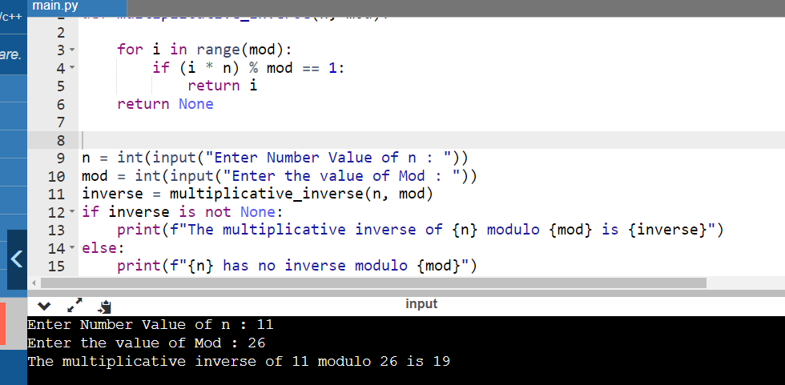

9.Write a program to implement Elgamal Cryptosystem to generate the pair of keys and then show the encryption & decryption of a given message
import random
import math

def is_prime(num):
"""
Checks whether the given number is prime or not.
"""
if num == 2:
return True
if num % 2 == 0 or num == 1:
return False
for i in range(3, int(math.sqrt(num)) + 1, 2):
if num % i == 0:
return False
return True

def find_primitive_root(p):

if not is_prime(p):
return None
factors = []
phi = p - 1
n = phi
for i in range(2, int(math.sqrt(n)) + 1):
if n % i == 0:
factors.append(i)
while n % i == 0:
n /= i
if n > 1:
factors.append(n)
for g in range(2, p):
flag = True
for factor in factors:
if pow(g, phi // factor, p) == 1:
flag = False
break
if flag:
return g
return None

def generate_keypair():
"""
Generates a keypair for ElGamal cryptosystem.
"""
p = random.randint(100, 1000)
while not is_prime(p):
p = random.randint(100, 1000)
g = find_primitive_root(p)
x = random.randint(2, p - 2)
y = pow(g, x, p)
return (p, g, y, x)

def encrypt_message(message, p, g, y):
"""
Encrypts the message using ElGamal cryptosystem.
"""
k = random.randint(2, p - 2)
a = pow(g, k, p)
b = (pow(y, k, p) * message) % p
return (a, b)

def decrypt_message(ciphertext, p, x):
"""
Decrypts the ciphertext using ElGamal cryptosystem.
"""
a, b = ciphertext
message = (b * pow(a, p - 1 - x, p)) % p
return message

# Generate a keypair
p, g, y, x = generate_keypair()
print("Public key (p, g, y):", (p, g, y))
print("Private key (x):", x)

message = int(input("Enter Message :"))
ciphertext = encrypt_message(message, p, g, y)
print("Ciphertext:", ciphertext)

# Decrypt the ciphertext
decrypted_message = decrypt_message(ciphertext, p, x)
print("Decrypted message:", decrypted_message)
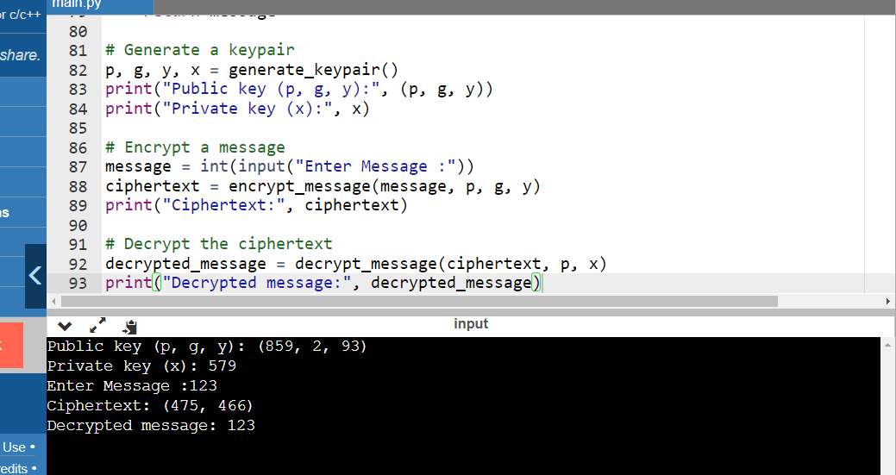
10. W.A.P. to implement RSA Algorithm to generate a pair of keys and show the encryption and decryption by using a given key pair
import random
import math

while True:
p = int(input("Enter The Prime Number first : "))
q = int(input("Enter The Prime Number Second: "))
if(p!=q):
break
else:
print("Values should be differentg")

message = input("Your Entered Message : ")

def generate_keypair(p, q):
n = p * q
phi = (p - 1) * (q - 1)
# Choose e such that e and phi(n) are coprime
e = random.randrange(1, phi)
g = math.gcd(e, phi)
while g != 1:
e = random.randrange(1, phi)
g = math.gcd(e, phi)
# Calculate the private key
d = pow(e, -1, phi)
# print((e, n), (d, n))
return ((e, n), (d, n))

public_key, private_key = generate_keypair(p, q)

def encrypt(public_key, plaintext):
e, n = public_key
ciphertext = [pow(ord(char), e, n) for char in plaintext]
return ciphertext

def decrypt(private_key, ciphertext):
d, n = private_key
plaintext = [chr(pow(char, d, n)) for char in ciphertext]
return ''.join(plaintext)

ciphertext = encrypt(public_key, message)
plaintext = decrypt(private_key, ciphertext)

print("Plaintext :", plaintext)
print("Ciphertext :", ciphertext)
print("Key pair : ",generate_keypair(p,q))

print("Decypted Values : ",decrypt(private_key,ciphertext))
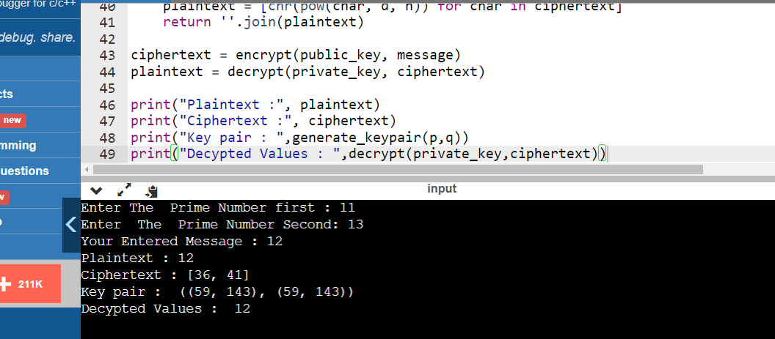

- Write a program to find out the Multiplicative inverse of a given number by using Extended Euclidean algorithm

def extended_euclidean_algorithm(a, b):
if b == 0:
return (a, 1, 0)
else:
q = a // b
r = a % b
(gcd, s, t) = extended_euclidean_algorithm(b, r)
return (gcd, t, s - q * t)

def multiplicative_inverse(a, m):

(gcd, s, t) = extended_euclidean_algorithm(a, m)
if gcd != 1:

return None
else:
return s % m

a = int(input("Enter the number whose inverse is to find : "))
m = int(input("Enter the modulo number : "))
inverse = multiplicative_inverse(a, m)
if inverse is None:
print(f"{a} has no multiplicative inverse modulo {m}")
else:
print(f"The multiplicative inverse of {a} modulo {m} is {inverse}")

